DAY 1
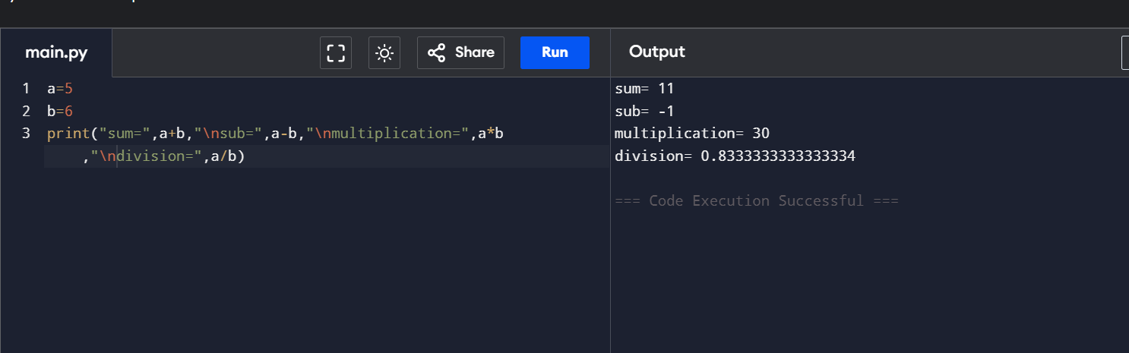
CALCULATOR

WATER JUG
